***SAT WARM-UP*:** The positive difference between k and  is   
the same as the positive difference between  and  . Which of the following is the value of k?  
a. 1/60  
b. 1/20  
c. 1/15  
d. 13/60  
e. 37/60

**Vocabulary**

3. Factor by grouping (four or more terms)  
a.    
  
  
  
  
b. 

c. 

prime polynomials

quadratic form

1. Factoring cubic polynomials : IMPORTANT - MEMORIZE

a. Sum of two cubes

b. Difference of two cubes  
  
  
NOTE: polynomials that can not be factored are called PRIME POLYNOMIALS

4. Higher Order : Look for difference of squares before difference of cubes.

a. 

b. 

2. Factor each polynomial. If the polynomial can’t be factored, write PRIME

a.  b.x3-400 c. 24x5 +3x2y3

This new function is called (f+g)(x)

5b. Solve 

4. Solving Polynomial Functions by Factoring – extends zero product property

a. 

b. 

5. In Class Practice # 1-13

6. Practice in Class #1-19

7. Honors Group Work

A standard shipping box measures *x* inches high. The width is 3.5 inches more than the height, and the length is 3 inches less than the height. The volume of the box is 561 cubic inches.

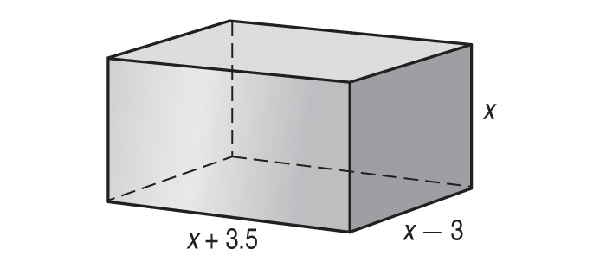

What is *x*?

5. Using Substitution for Quadratic Pattern  
a. 

Practice at Home: 5.5 # 50,52,54,56,58,60,62,64,66,67,68,69