3. Polynomial Functions : polynomial equation in one variable  
 ex 

a. Evaluating (if you know an element in the domain can find match in range)  
 The volume of air in lungs during a 5-second respiratory cycle can be   
 modeled by  , where v is the volume in  
 liters and t is the time in seconds. Find the volume of air in the lungs 1.5   
 seconds into the respiratory cycle

***SAT WARM-UP*:** If  , what is  ?

**Vocabulary**

polynomials in one variable  
leading coefficient  
polynomial function  
power function  
quartic function  
quintic function  
end behavior

1. Power Functions – Use your calculator  
What do they look like?

3b. Evaluating functions for variables and algebraic expressions  
 If  find 

2. Polynomials in one variable:   
 Standard Form:

Degrees and Leading Coefficient

Polynomial Expression Degree Leading Coefficient  
Constant  
linear  
Quadratic  
Cubic  
General

a.  b.  c. 

This new function is called (f+g)(x)

5. Zeros of Even and Odd Degree Functions  
Odd degree functions will always have and odd number of real zeros

Even degree functions will always have an even number or no real zeros.

For the graphs, describe the end behavior, odd or even degree polynomial?, and number of real zeros.

a. b. c.

3c. If  find 

4. Polynomial Functions and End Behavior

a. constant function b. linear function c. quadratic function

d. Cubic function e. quartic function f. quintic function

6. In Class Practice # 1-12

7. Honors Group Work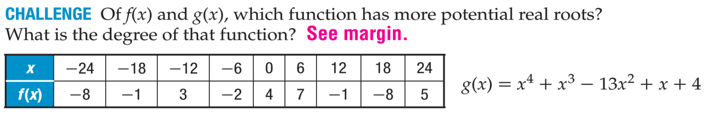

Practice at Home: 5.3 # 14,16,20,24,28,30,32,34,37,38,40,47,48,49,50