2. Simplifying Monomials:   
 Monomial – simplified when no powers of powers, each base appears only  
 once, all fractions are in simplified form, and no negative  
 exponent.

a.  b. 

c.  d. 

***SAT WARM-UP*:** The expression  is equivalent to what expression?

a. 35  
b. -12i  
c. -12 + i  
d. 35-12i  
e. 37-12i

**Vocabulary**

Simplify

degree of a polynomial

1. IMPORTANT: Properties of Exponents

a. Product of Powers

b. Quotient of Powers

c. Negative Exponent

d. Power of a Power

e. Power of a Product

f. Power of a Quotient

g. Zero Power

3. a. Monomials have no fractional exponents or variables in denominator  
 b. Degree of a Polynomial is the degree of the monomial with the greatest  
 degree.

Determine whether each is a polynomial. It if is, state the degree:

a.  b. 

c.  d. 

This new function is called (f+g)(x)

7. In Class Practice # 1-15

4. Simplifying Polynomial Expressions - Remove parenthesis, add like terms  
a.  

b. 

8. Honors Group Work

**A. THE EARTH** Earth’s diameter is approximately 1.2756 × ${10}^{4}$ kilometers.The surface area of a sphere can be found using the formula *SA* = 4π $r^{2}$

What is the approximate surface area of Earth?

**2. VOLUME** The volume of a rectangular prism is given by the product of its length, width, and height. Samantha has a rectangular prism that has a length of $b^{2}$ units, a width of *a* units, and a height of *ab* + *c* units.

What is the volume of Samantha’s rectangular prism? Express your answer in simplified form.

**3. CONSTRUCTION** A rectangular deck is built around a square pool. The pool has side length *s*. The length of the deck is 5 units longer than twice the side length of the pool. The width of the deck is 3 units longer than the side length of the pool. What is the area of the deck in terms of *s*?

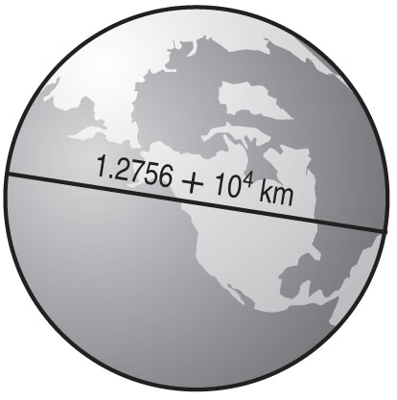

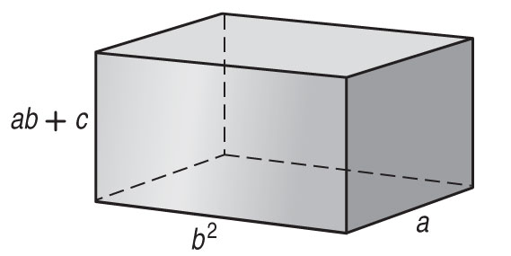

5. Use the distributive property to multiply polynomials:  
 

6. Multiplying Polynomials – use box method – less mistakes   


Practice at Home: 5.1 # 24-27,43,44, 45,47,49,51, 55,57,59