2. Writing Functions in Vertex form -   
a.  b. 

***SAT WARM-UP*:** The sum of integers x and y is 495. The units digit of x is 0. if x is divided by 10, the result is equal to y. What is the value of x?

a. 40  
b. 45  
c. 245  
d. 250  
e. 450

**Vocabulary**

vertex form

1. Vertex Form of Quadratic:

Vertex:

Axis of Symmetry

if a>0 the graph opens up  
if a<0 the graph opens down  
  
h is the horizontal translation  
x-h moves to the right  
x+h moves to the left

k is the vertical translation  
+k moves up  
-k moves down

a is the dilation

|a|>1 stretched vertically (thinner)  
|a| is a fraction compressed vertically(wider)

3. Writing an Equation, given a graph (Use vertex and substitute point)

a.

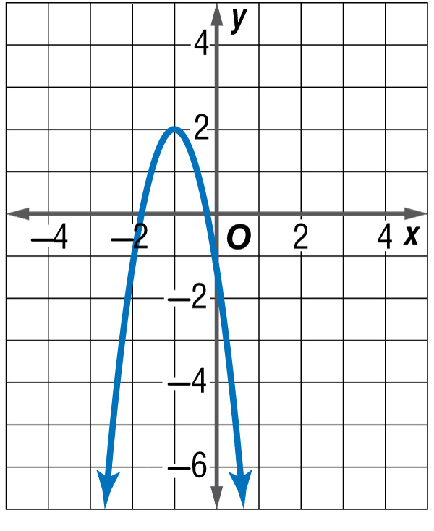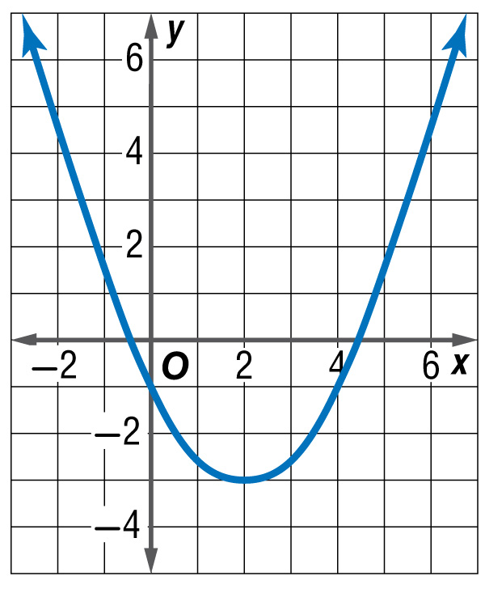

b.

This new function is called (f+g)(x)

5. In Class Practice # 1-7

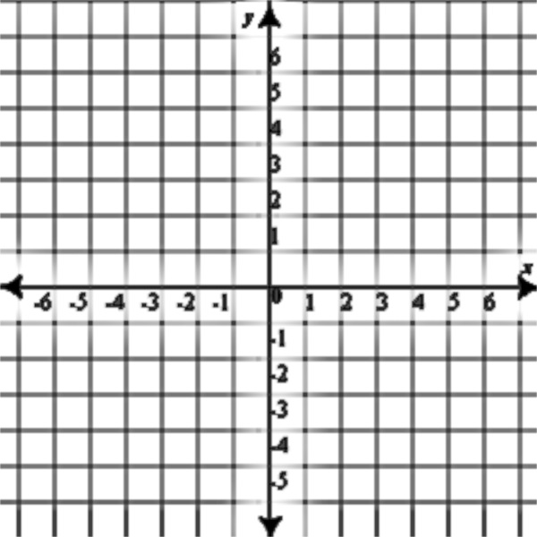

4. Graphing from vertex form



6. Honors Group Work

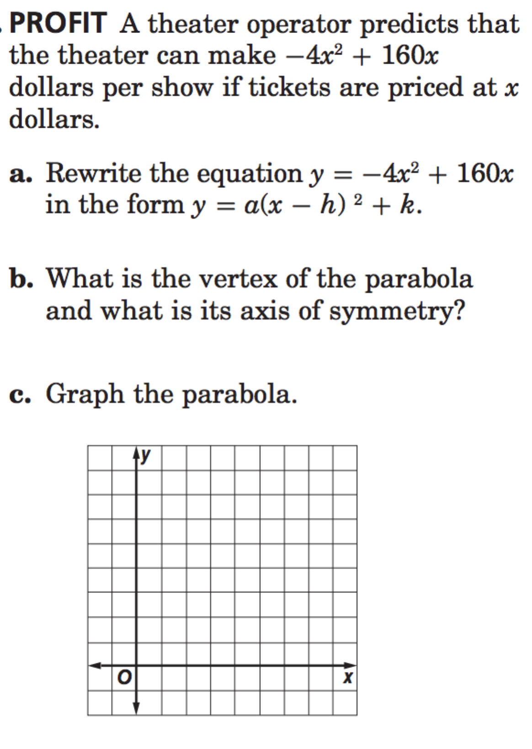

4b. 



Practice at Home: 4.7 #9,11,13,19,22,26,33,36,37,42