***SAT WARM-UP*:** The total area of a rectangle is 

Which factors could represent the length and width?

a.  units and units  
b. units and units  
c.  units and units  
d. units and  units  
e. units and  units

**Vocabulary**

2. Fundamental Theorem of Algebra: Every polynomial with degree greater than 0 has at least one root in the set of complex number. ??

Corollary to the Fundamental Theorem of Algebra: A polynomial of degree n has exactly n roots in the set of complex number, including repeated roots.

Solve each equation. State the number and type of roots  
a. 

b. 

Fundamental Theorem of Algebra

Corollary to the Fundamental Theorem of Algebra

1. How zeros, roots, factors, and intercepts are related: if p(x) is a polynomial, then

if c is a zero of p(x),

c is a root or solution of p(x)=0

and x-c is a factor of the polynomial

and if c is a real number, than (c,0) is an x intercept of the graph of p(x)

Example:

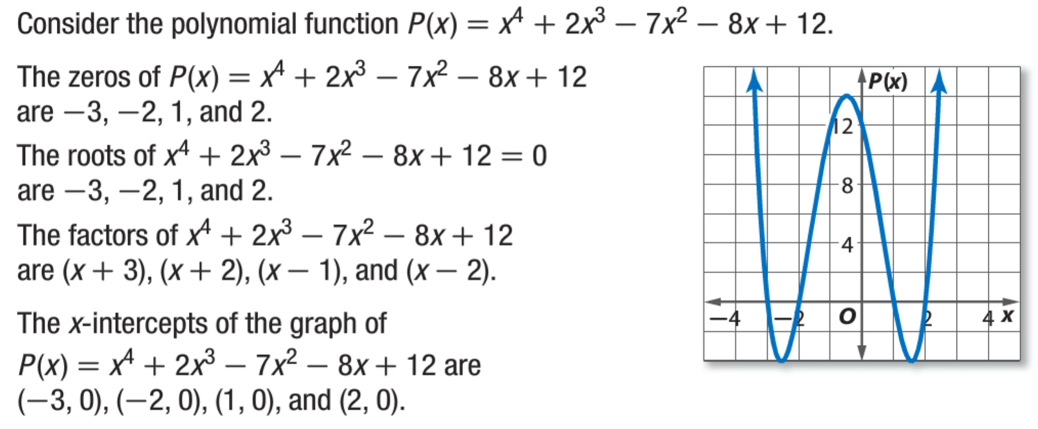

3. Decartes Rule of Signs – helps you know the number of positive and negative real zeroes. How does the rule work?  
a. example: 

1. For # of Positive real zeros:

2. For # of Negative real zeros:

So then we can calculate the imaginary zeros.

This new function is called (f+g)(x)

5. Complex Conjugates Theorem: if a+bi is a zero, then its conjugate,   
 a-bi is also a zero.

example: Write a polynomial function of least degree with integral coefficients, the zeros of which include 4, and 4-i.

3. b State the possible number of positive real zeros, negative real zeros, and imaginary zeros of 

5. In Class Practice # 1-13

4. Find ALL zeros – For NOW, use your calculator to find one, then use synthetic division to get the depressed polynomial and repeat until all zeros are known.   
ex. 

6. Practice in Class #1-16

7. Honors Group Work: Sketch the graph of a polynomial function with

a. 3 real/2 imag zeros b. 4 real zeros c. 2 imaginary zeros

Practice at Home: 5.7 # 17,21,25,27,29,31,33,35,39,43